**X Alignment Example Problem**

This example problem has an angio material where all of the fibers are oriented in the same direction.

**Geometry**

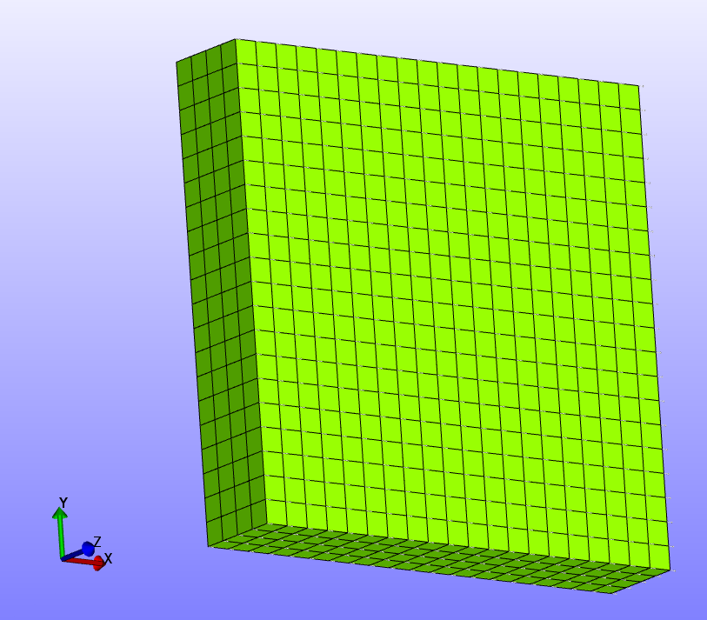

**Boundary Conditions**

-Z face fixed in z.

-Y face fixed in y.

-X face fixed in x.

All fibers are oriented in +x direction.

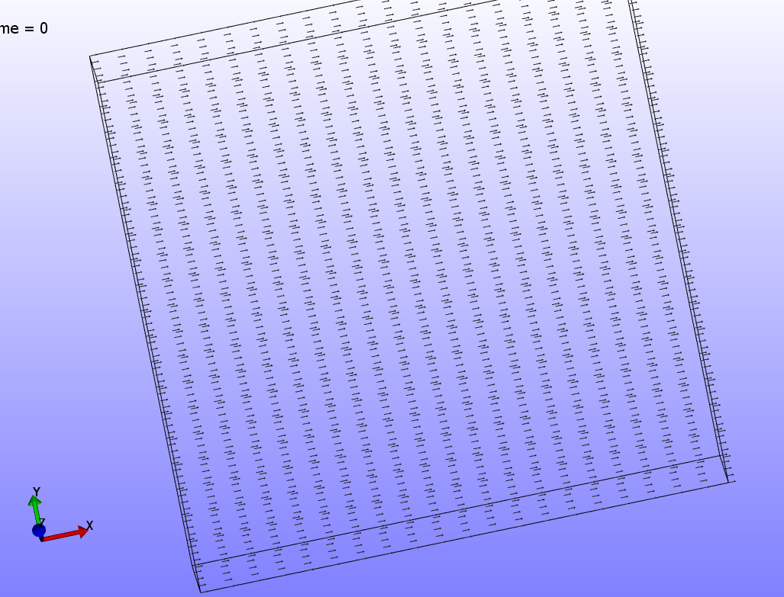

A visualization of the fibers used in this model.

**Material(s)**

The material used in this model is an angio material.

**Results**

Vessel growth is directed by all of the fiber being oriented in the +x direction.